Leakage Test Setup Measurement

I made the setup measurement for the Leakage test. Measured with 20Vrms 60Hz input signal.
Results of the measurement :
V1 = 20,91Vrms
I1 = 10.74 mA rms
V3 = 5,325Vrms

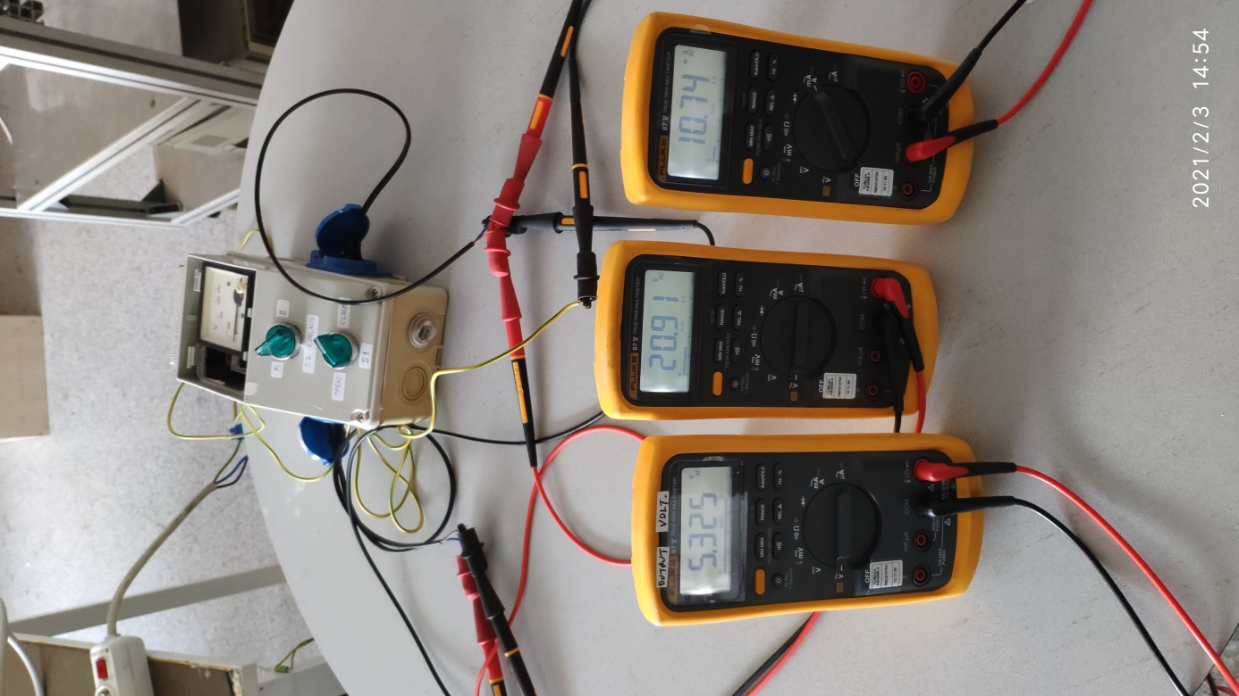

Referenced resources:

